**Project Overview**

Deforestation is a major global concern, contributing to climate change, habitat destruction, and loss of biodiversity. Traditional methods of monitoring deforestation rely on manual surveys and limited on-ground observations, making them time-consuming and inefficient. This project aims to leverage satellite imagery and deep learning techniques to automatically detect and monitor deforestation areas over time. By analyzing sequential satellite images, the system can identify patterns of land cover changes, detect areas at risk, and provide valuable insights for environmental conservation and policy-making. The use of advanced machine learning techniques ensures accurate classification of forested and deforested regions, helping organizations and governments take timely actions to combat deforestation.

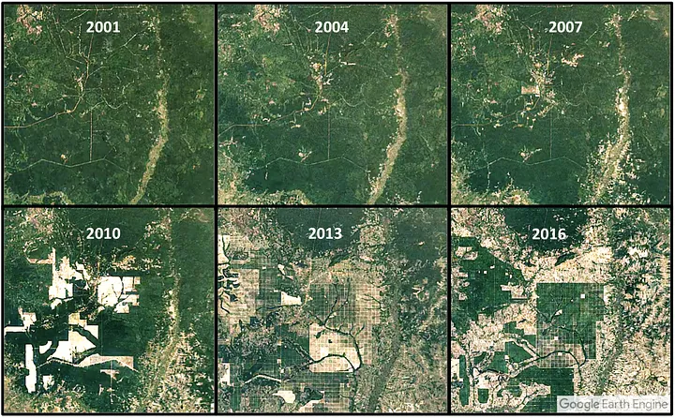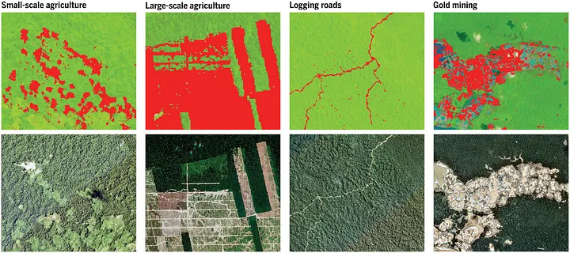

**Objectives**

* **Data Processing:** Preprocess high-resolution, multi-band satellite images to extract relevant features for land classification.
* **Deep Learning Model:** Train Convolutional Neural Networks (CNNs) to distinguish between different types of land cover, focusing on detecting deforested areas.
* **Change Detection:** Utilize sequential images to monitor changes in forest cover over time, identifying areas affected by deforestation.
* **Visualization & Analysis:** Create interactive visual representations of deforestation trends, helping stakeholders understand the impact of land-use changes.
* **Environmental Impact Assessment:** Provide data-driven insights to assist policymakers, conservationists, and researchers in formulating strategies for forest preservation.

**Outcome**

The project will result in a powerful, AI-driven system capable of analyzing satellite images to detect and track deforestation trends. The insights generated from the system can support government agencies, environmental organizations, and researchers in making informed decisions for conservation efforts. This technology-driven approach enables proactive monitoring, improving global efforts to combat deforestation and mitigate its impact on the environment.

**Dataset:** use (planets_dataset) from Kaggle using Kaggle API

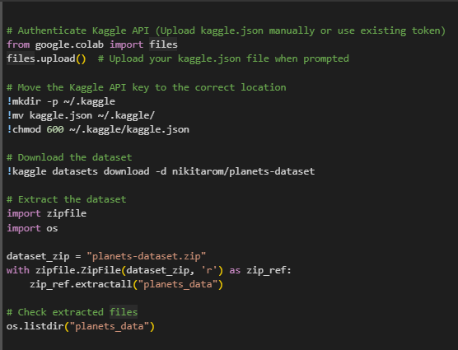

**Kaggle Dataset Link:**

[**https://www.kaggle.com/datasets/nikitarom/planets-dataset**](https://www.kaggle.com/datasets/nikitarom/planets-dataset)

**Models:**

**for Satellite Image Analysis for Deforestation Monitoring, the following models are suitable:**

1. Convolutional Neural Networks (CNNs) – Used for land classification from satellite images.
   * Example: ResNet, VGG16, or EfficientNet for extracting spatial patterns.
2. Change Detection Models – Used to analyze sequential images and detect deforestation.
   * Example: Siamese Networks or Autoencoders for comparing images over time.

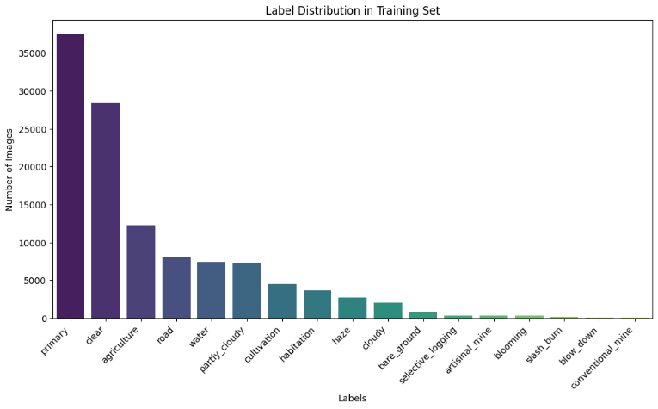

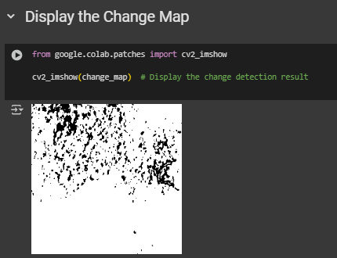

**Environment:**

Google colab

Framework : torch

**Google colab link :**

[**https://colab.research.google.com/drive/13QgEnZrTENGqQL2NXdPVGRGvSaGBhsMO?usp=sharing**](https://colab.research.google.com/drive/13QgEnZrTENGqQL2NXdPVGRGvSaGBhsMO?usp=sharing)